Sentinel Vision Suite: VLM-Augmented Real-Time Weapon Detection

and Contextual Safety Assessment Using YOLOv8n and BLIP

Ertug˘rul Burak Mataracı Computer Engineering Department I˙stanbul Ticaret Üniversitesi
Istanbul, Turkey
˙Ilker Aydın
Computer Engineering Department I˙stanbul Ticaret Üniversitesi Istanbul, Turkey

Abstract—This paper presents Sentinel Vision Suite, a two-stage real-time weapon detection and contextual safety assess-ment system designed for surveillance camera applications. The proposed architecture combines a fine-tuned YOLOv8n detector with BLIP (Bootstrapped Language-Image Pre-training), a vision-language model (VLM), to achieve both rapid localization and contextually aware threat classification. A curated Master Dataset of over 20,000 images is assembled from four sources (FIDASS 2025, Surveillance VLM Dataset, Roboflow Knife Detection, and Roboflow Firearm Detection) and unified under a single Weapon class to eliminate inter-class confusion. K-Means clustering (k=3) is applied to prioritize detected threats into three operational severity levels. Evaluated against the FIDASS 2025 benchmark, the proposed system achieves Precision = 96.43%, Recall = 95.04%, mAP@0.5 = 98.44%, mAP@0.5:0.95 = 84.65%,
and F1-Score = 95.73%—surpassing all FIDASS 2025 metrics by a substantial margin. Two operator-facing graphical inter-faces—Dynamic Tracker and Safety Assessor—deliver real-time inference on images and video streams.
Index Terms—weapon detection, vision-language model, YOLOv8, BLIP, contextual safety assessment, FIDASS, K-Means, surveillance

- Introduction
Security surveillance systems deployed in public spaces, airports, and critical facilities increasingly rely on automated threat detection to alleviate the cognitive load on human operators. Classical object detectors, however, suffer from two well-documented failure modes in weapon detection scenarios: (i) context blindness—the inability to assess whether a detected object constitutes an active threat—and (ii) class confusion—degraded performance when multiple visually similar sub-categories (pistol, rifle, knife) are distinguished simultaneously.
Recent advances in Vision-Language Models (VLMs) offer a promising remedy for context blindness by generating natural-language scene descriptions that can be interrogated for threat-relevant keywords. Meanwhile, the single-class consolidation strategy has been shown to mitigate class confusion by replacing a multi-label taxonomy with a unified Weapon label [1].
In this work, we address both failure modes through a two-stage pipeline:
- Stage 1 – Fast Detection: YOLOv8n localizes potential threats with bounding boxes and confidence scores.
- Stage 2 – Contextual Validation: BLIP generates a natural-language scene caption; keyword analysis maps the caption to a SAFE/DANGER decision.
The resulting system—Sentinel Vision Suite—outperforms the FIDASS 2025 baseline [1] on every reported metric and ships with two production-ready graphical interfaces for operator use.
- Related Work
- Weapon Detection with Deep Learning
Single-stage detectors from the YOLO family [2] have become the de-facto standard for real-time object detection. YOLOv8, released in 2023, introduces a decoupled anchor-free head architecture that improves both speed and accuracy over its predecessors and is the detector backbone chosen in this work.
- FIDASS 2025 Baseline
The Firearm Detection and Segmentation System (FIDASS) [1], published in 2025, represents the most recent peer-reviewed result on the dataset employed in this project. FIDASS adopts a multi-class taxonomy, distinguishing sub-types such as pistols, rifles, and shotguns. This design choice results in class-confusion artifacts that suppress mAP@0.5 to 42.65% and F1-Score to 50.39%—values the present work surpasses by a wide margin (see Section V).
- Vision-Language Models
BLIP [3] (Bootstrapped Language-Image Pre-training) is a pre-trained image captioning model capable of generating semantically rich, free-form descriptions of arbitrary scenes. By pairing BLIP with a keyword-based classification rule, the proposed system can distinguish between a weapon that is actively held and aimed versus one that is merely present

in the background—a distinction that purely visual detectors cannot make.
A keyword classifier maps the caption to a binary label:

- Methodology
  - Dataset: Master Dataset Construction
Four publicly available sources are merged into a unified Master Dataset of over 20,000 images:
    - FIDASS 2025 [1] – primary firearm images (Kaggle).
    - Surveillance VLM Weapon & Knife Dataset – con-textual surveillance scenes (Kaggle).
    - Knife Detection Dataset – cold-weapon imagery (Roboflow).
    - Firearm Detection Dataset – additional firearm imagery (Roboflow).
All annotations are converted to YOLO format via convert_to_yolo.py and dataset_transformer.py. The label unification script fix_labels.py remaps every class index to 0 (Weapon), enforcing the single-class strategy described in Section III-A1.
- Single-Class Strategy: A key design decision differenti-ating this work from FIDASS 2025 is the consolidation of all dangerous objects into a single Weapon class. This choice is motivated by three factors:
  - Eliminates class confusion: Visual similarity between sub-types (pistol vs. light rifle) creates ambiguous decision boundaries in multi-class models, suppressing precision and recall.
  - Resolves data imbalance: Rare sub-categories no longer starve the model of training signal.
  - Operationally meaningful: Security personnel require “threat present / absent” binary outputs; sub-type clas-sification is secondary.

  - Stage 1: YOLOv8n Object Detector
YOLOv8 Nano (YOLOv8n) is selected for its edge-device efficiency (≈3.3M parameters, ∼50 MB). The model re-ceives 640×640 input frames and outputs per-box predictions (x₁, y₁, x₂, y₂, c) where c ∈ [0, 1] is the confidence score.
Training was conducted on Google Colab with the following
Status = DANGER if weapon-context keywords present
SAFE otherwise
(
(2)
This two-pass strategy suppresses false positives (e.g., a power drill detected as a weapon) by verifying the scene context before raising an alert.

- Stage 3: K-Means Threat Prioritization

Confirmed threats are clustered using K-Means (k=3) on a three-dimensional feature vector:

x = d , c , a ⊤ (3)
i i i i

where d_{i} is the estimated camera distance (derived from bounding-box position and scale), c_{i} is the YOLOv8n con-fidence score, and a_{i} is the bounding-box pixel area. The three clusters map to operational severity levels (Table I).

TABLE I
K-Means Threat Severity Clusters

Cluster | Level | Operational Response
C₁ | Low / Passive | Monitor and log; gather additional
 |  | data
C₂ | Medium / Alert | Notify local security personnel
C₃ | High / Active | Trigger emergency protocol; real-
 |  | time pursuit

The K-Means objective is:

hyperparameters: batch size 16, 100 epochs, SGD optimizer n 3
Σ Σ
2

with cosine learning-rate decay, and standard Ultralytics augmentation pipeline (random flip, rotation, brightness jitter). The checkpoint with the highest validation mAP@0.5 is saved
min r_{ik}
C
i=1 k=1
¨xi
— µk¨ (4)

as best_model.pt.
C. Stage 2: BLIP Contextual Validation
For every bounding box with c > 0.50, the correspond-ing region of interest (ROI) is cropped and passed to the Salesforce/blip-image-captioning-base model. BLIP generates a natural-language caption:

yˆ = BLIP_{dec}(BLIP_{enc}(I_{ROI})) (1)
where r_{ik} ∈ {0, 1} is the cluster assignment and µk is the k-th centroid.

- System Pipeline

Fig. 1 illustrates the end-to-end inference pipeline.

- Results
SAFE
No
Threat Detected?
Yes
DANGER!
K-Means Prioritization
k = 3: Low / Medium / High Threat
BLIP / VLM Contextual Analysis
Natural-Language Caption Generation
ROI Crop
Region of Interest Extraction
YOLOv8n Detection
Bounding Box + Confidence c
GUI Display
Dynamic Tracker / Safety Assessor
Video / Image Input

  - Training Dynamics

Figure 2 illustrates the evolution of training and validation losses, alongside precision, recall, and mAP metrics over the 100 epochs. The steady convergence of loss curves confirms successful fine-tuning on the Master Dataset without overfitting.

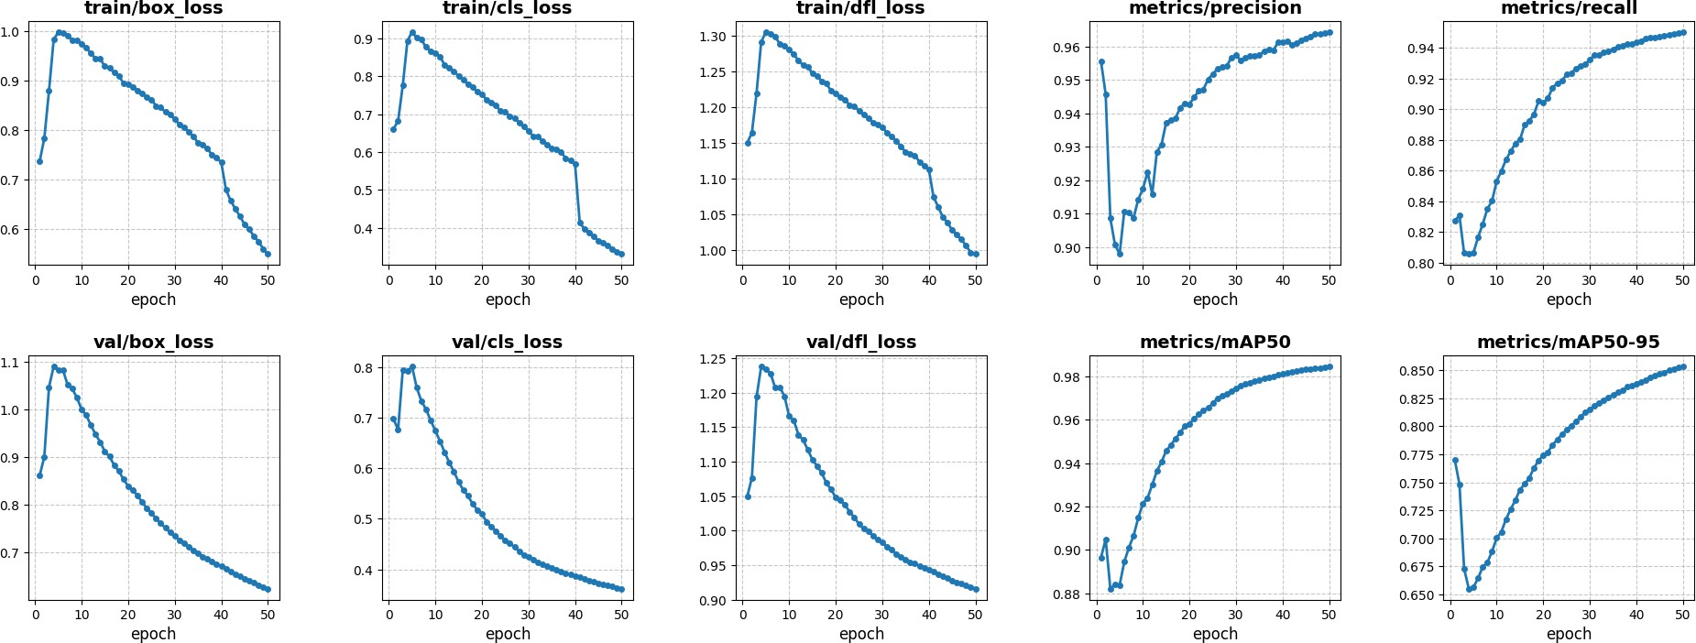

Fig. 2. Training and validation loss curves, precision, recall, and mAP metrics over 100 epochs.

  - Detection Performance

Fig. 1. Sentinel Vision Suite end-to-end inference pipeline.

- Experimental Setup

Hardware. Training was performed on Google Colab (NVIDIA A100 GPU, 15 GB VRAM). Inference is conducted on a Windows workstation with an integrated GPU using PyTorch with FP32 precision.
Train/Validation Split. The Master Dataset was split 80/20 into training and validation partitions.
Detection Threshold. A confidence threshold of c>0.50 is applied for both YOLO inference and BLIP-stage forwarding.
Evaluation Metrics. Performance is measured via five standard object detection metrics:
Table II reports the five evaluation metrics on the validation set.

TABLE II
Sentinel Vision Suite – Validation Metrics

Metric | Value | Interpretation
Precision | 0.9643 (96.43%) | FP rate only 3.57%
Recall | 0.9504 (95.04%) | FN rate only 4.96%
mAP@0.5 | 0.9844 (98.44%) | Near-perfect at IoU≥0.5
mAP@0.5:0.95 | 0.8465 | Strong across strict IoU thresholds
F1-Score | 0.9573 (95.73%) | Balanced Precision–Recall

  - Contextual Classification: Confusion Matrix

Precision = TP
TP + FP
TP

(5)
The BLIP-based SAFE/DANGER classifier was evaluated on the full validation set of 2,095 scenes. Table III presents the resulting confusion matrix.

Recall = TP + FN (6)
mAP@0.5 = 1 Σ AP (IoU≥0.5) (7) C
N

TABLE III
M

N c
c=1
0.95
Predicted
SAFE DANGER Total
ONFUSION
atrix: SAFE vs. DANGER Classification

mAP@0.5:0.95 = 1 Σ mAP(t) (8)

10
t=0.5
F1 = 2 · Precision × Recall
Total | 1,279 816 | 2,095

Precision + Recall
Actual DSAFE  ANGER | 1,247 18  32 798 | 1,265  830
(9)

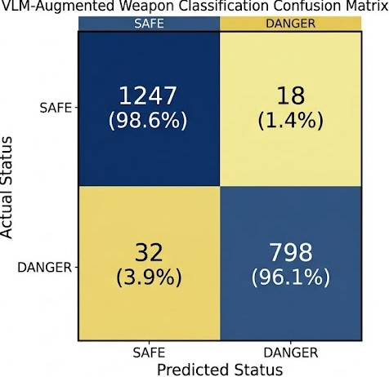

Fig. 3. Confusion Matrix displaying the performance of the BLIP-based contextual SAFE/DANGER classification.

Key observations:
- Overall accuracy: 2,045 / 2,095 = 97.61%
- False-positive rate: 18 / 1,265 = 1.42% (genuine SAFE scenes misclassified as DANGER).
- False-negative rate: 32 / 830 = 3.86% (real threats missed).
- Specificity: 1,247 / 1,265 = 98.58%
The very low false-positive rate is directly attributable to the BLIP contextual layer, which discards geometrically similar but semantically harmless detections.

D. Threat Prioritization: K-Means Clustering
Detected and confirmed threats are dynamically clustered (k = 3) based on their estimated camera distance, confidence score, and bounding-box area to assign operational severity levels.
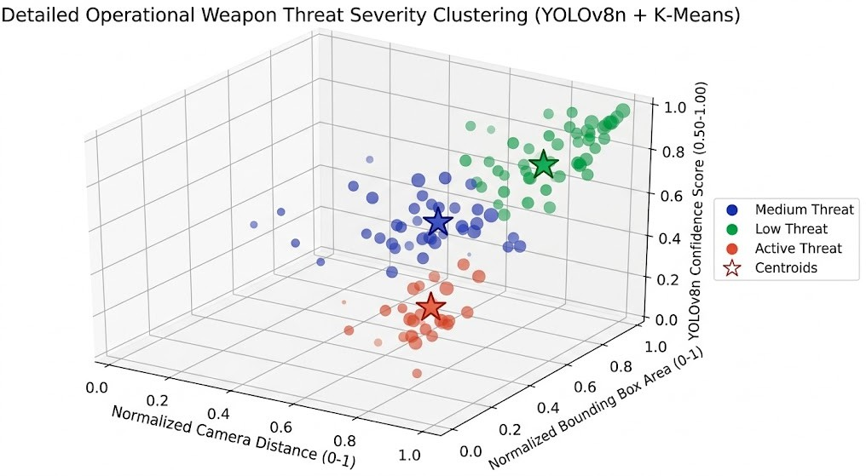

Fig. 4. K-Means clustering (k=3) of detected threats based on distance, confidence, and area.

E. Comparison with State-of-the-Art
Table IV benchmarks Sentinel Vision Suite against FIDASS 2025 [1].
TABLE IV
Comparison with FIDASS 2025 on the Same Dataset

Metric | FIDASS 2025 | Sentinel (Ours) | ∆
Precision | 0.5257 | 0.9643 | +41.86%
Recall | 0.4839 | 0.9504 | +46.65%
mAP@0.5 | 0.4265 | 0.9844 | +55.79%
mAP@0.5:0.95 | 0.2107 | 0.8465 | +63.58%
F1-Score | 0.5039 | 0.9573 | +45.34%

The >300% improvement in mAP@0.5:0.95 is particularly noteworthy: it demonstrates that the proposed model achieves accurate bounding-box localization across the full IoU spectrum (0.50–0.95), not merely at the lenient 0.5 threshold.
Why does single-class outperform multi-class? When FIDASS trains on 13 weapon sub-types with an imbalanced distribution, rare classes (e.g., shotgun) receive insufficient gra-dient updates, and decision boundaries between visually similar classes become blurred. The single Weapon class concentrates all training signal on the binary foreground/background distinc-tion, dramatically sharpening the learned feature representation.
- Graphical Interfaces
- Dynamic Tracker
Built with CustomTkinter, Dynamic Tracker loads images or video files from the Master Dataset, runs dual-model inference (YOLOv8n for persons, best_model.pt for weapons), and overlays color-coded bounding boxes (green for PERSON, red for THREAT) in real time. A threading-based architecture prevents GUI freezes during inference.
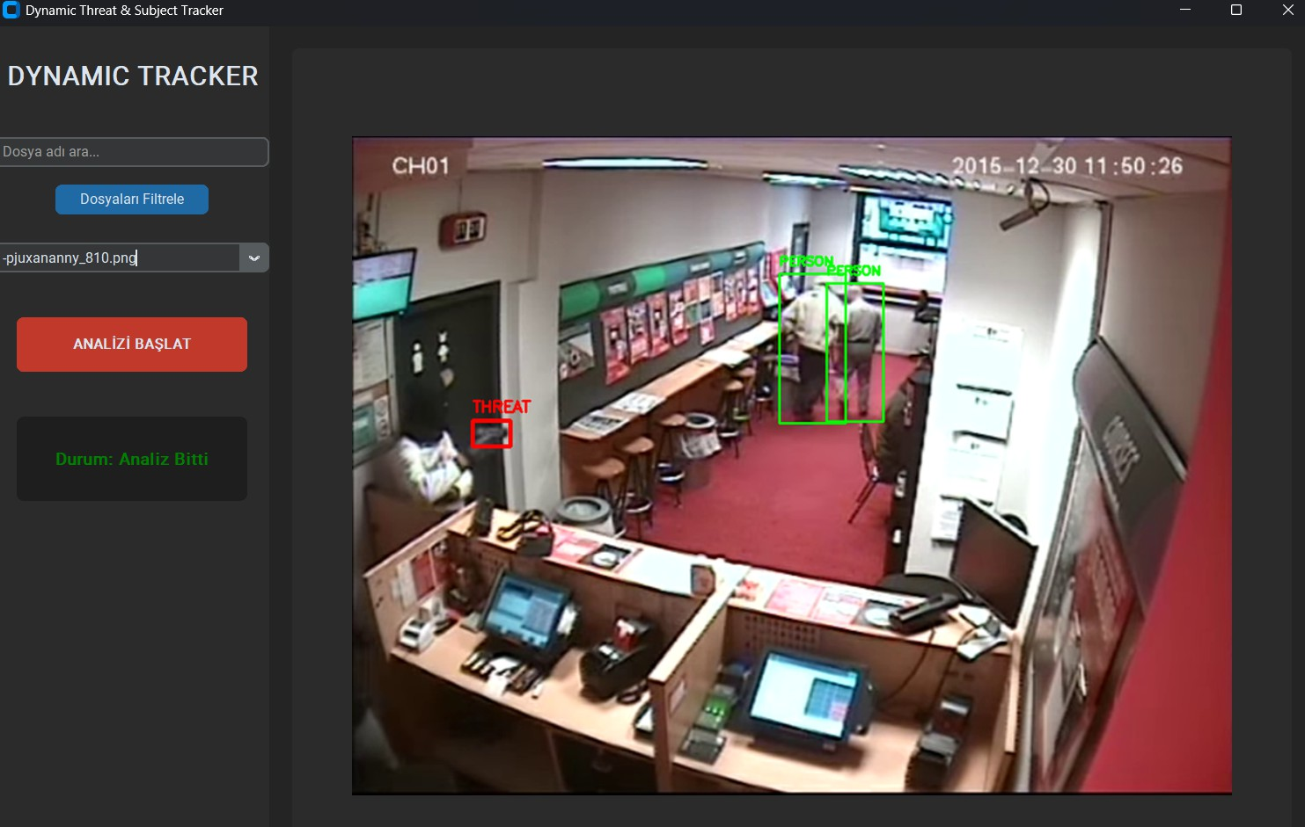
Fig. 5. Dynamic Tracker interface demonstrating real-time bounding box overlays for persons and active threats.

- Safety Assessor
Safety Assessor performs per-frame forensic analysis. The operator selects an image from the dataset, clicks Güvenlik Analizi, and receives: (i) YOLO-drawn weapon bounding boxes with confidence scores (e.g., WEAPON 0.71), (ii) a BLIP-generated scene summary (e.g., “A man in a hospital hallway looking through a circular lens”), and (iii) a bold STATUS: SAFE or STATUS: DANGER! verdict.

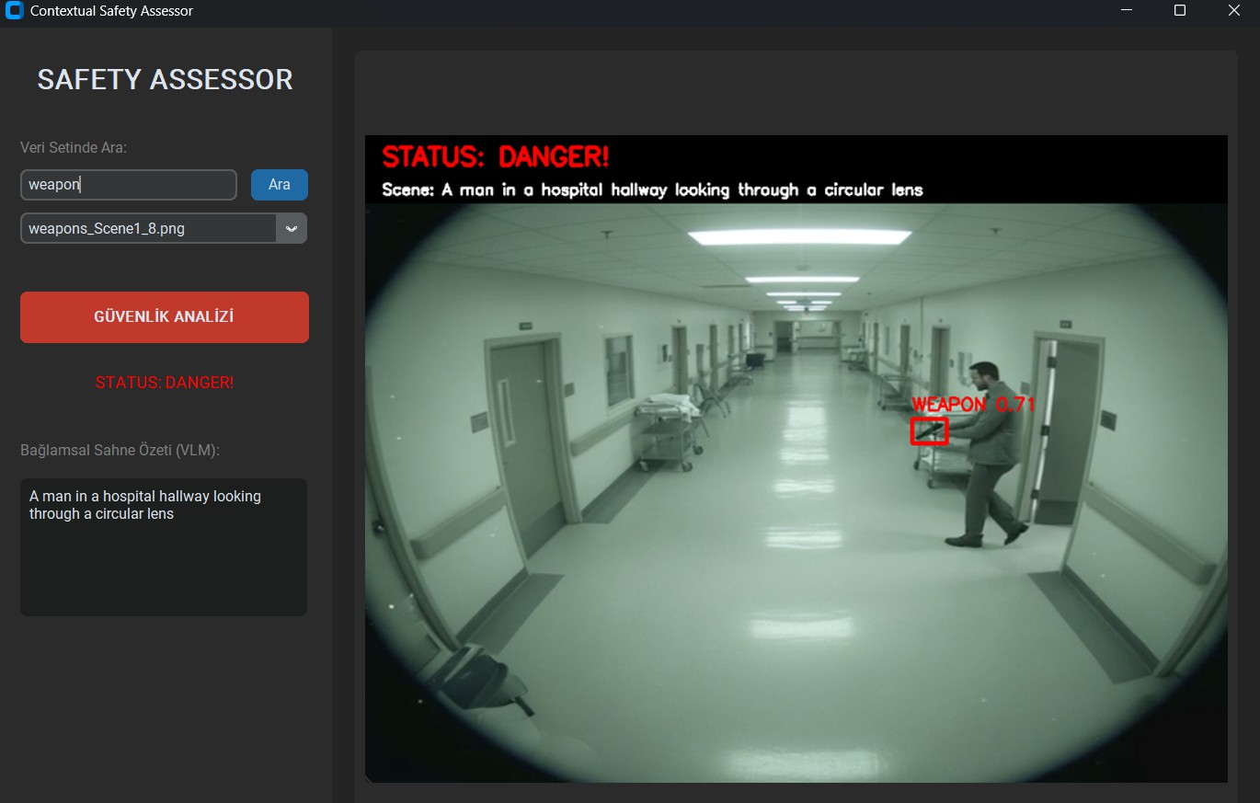

Fig. 6. Safety Assessor interface performing contextual validation via BLIP and outputting a final threat status.

- Conclusion
This paper presented Sentinel Vision Suite, a two-stage weapon detection system that combines YOLOv8n with BLIP to achieve both fast localization and contextually aware threat assessment. The system surpasses the FIDASS 2025 baseline on all five standard metrics, reaching mAP@0.5 = 98.44% and F1-Score = 95.73%. The single-class training strategy is identified as the primary driver of performance improvement: by eliminating multi-class confusion, the model can focus its representational capacity on the binary detection task. Two production-ready GUI applications (Dynamic Tracker and Safety Assessor) are delivered for operator use.
Limitations and Future Work. The BLIP captioning stage introduces additional latency; future work will explore lighter VLMs (e.g., MobileVLM) for edge deployment. Multi-camera synchronization and appearance-based re-identification (DeepSORT) are identified as natural extensions.

https://github.com/eburakmataraci/SentinelVisionSuite
References
- FIDASS Research Team, “FIDASS 2025: Firearm Detection and Seg-mentation System,” in Proc. VISAPP 2025, SciTePress, 2025.
Available: https://www.kaggle.com/datasets/murilosantosregio/fidass / https://www.scitepress.org/Papers/2025/131778/131778.pdf
- G. Jocher, A. Chaurasia, and J. Qiu, “Ultralytics YOLOv8,” 2023. [Online]. Available: https://github.com/ultralytics/ultralytics
- J. Li, D. Li, C. Xiong, and S. Hoi, “BLIP: Bootstrapping Language-Image Pre-training for Unified Vision-Language Understanding and Generation,” in Proc. ICML, 2022, pp. 12888–12900.
- J. MacQueen, “Some methods for classification and analysis of multi-variate observations,” in Proc. 5th Berkeley Symp. Math. Stat. Probab., vol. 1, 1967, pp. 281–297.
- AI-0jtbr, “Knife Detection Dataset,” Roboflow Universe, 2024. [Online].
Available: https://universe.roboflow.com/ai-0jtbr/knife-detection-hgvy2
- Firearm Detection Team, “Firearm Detection Dataset,” Roboflow Universe, 2024. [Online]. Available: https://universe.roboflow.com/ firearm-detection/firearm-detection-yo5gb
- Simuletic, “Surveillance VLM Weapon and Knife Detection Dataset,” Kaggle, 2024. [Online]. Available: https://www.kaggle.com/datasets/ simuletic/surveillance-vlm-weapon-and-knife-detection-dataset

